Session : 1
Task : 1 Open Instagram's home page in Chrome, right-click on a post image, and use Inspect Element to find the exact HTML tag and CSS class used for the image container. Write down the tag name and class.
- HTML Tags:- HTML tag, Head, body, Link tag, Title , style, script, img, meta, div, ul, li, button, article, svg, polyline, line.
- CSS Class:- x78zum5 xdt5ytf xg6iff7 xippug5 x1n2onr6, x1lliihq x1n2onr6 x9bdzbf, x5yr21d xu96u03 x10l6tqk x13vifvy x87ps6o xh8yej3

Task: 3 Use Chrome DevTools to change the background color of your name (in myprofile.html) to any color you like, live in the browser, without editing the HTML file.

- 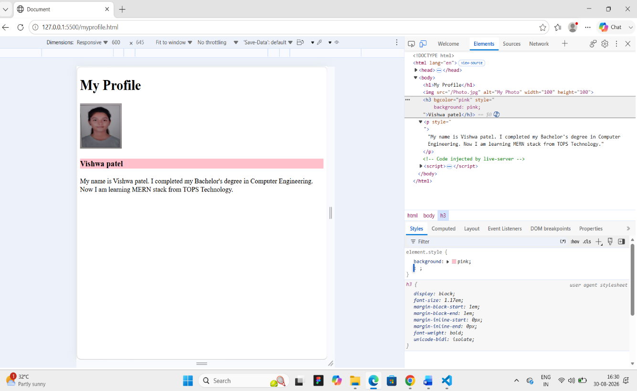

Task: 4 Draw a diagram or write a list showing the DOM structure (parent-child relationships) of your myprofile.html page. Include at least 3 levels (html > body > your content). what is the task says to do and how
- html
- │
- |── head
- │ └── title
- │
- └── body
- │
- |__img
- |
- |── h1
- │ └── "Vishwa Patel"
- │
- |── p
- │ └── "I am a Computer Engineering graduate..."

